“Climbing Mount Improbable” by Richard Dawkins.

All shell shape structures can be generated using 4 variables:
- Flare (W)
- Verm (D)
- Spire (T)
- Shape (?)

Flare – is a measure of the expansion rate of the spiral. If Flare is 2, for every complete turn round the spiral, the spiral opens out twice its previous size. This is true of Figure 6.2(b)
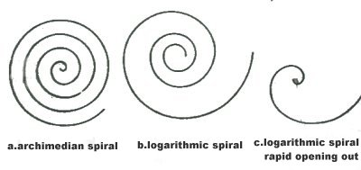

Flare has a minimum value of I (smaller values would indicate a shrinking rather than a growth process) and no fixed maximum value.

Verm – gets its name from ‘vermiform’, which means ‘worm-shaped’. Figure 6.3a and 6.3b have identical flare values (2) but Figure 6.3b has a higher verm score (0.7) than 6.3a’s 0.5. A verm of 0.7 means that the distance from the centre of the spiral to the inner margin of the tube is 70 per cent of the distance from the centre of the spiral to the outer margin of the tube.

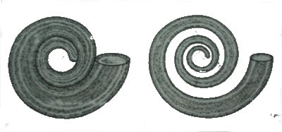

The verm gene’s value is a proportion, varying from 0 to just below I ( a verm value of I would indicate a tube so thin and wormy as to be non existent).

Spire – Think of the expanding spiral as moving sideways as it expands, making a conical shape like a top. Spire is the rate at which successive whorls of the spiral creep along the length of the cone. Nautilus happens to have a spire value of 0: all of its successive windings are in one plane.

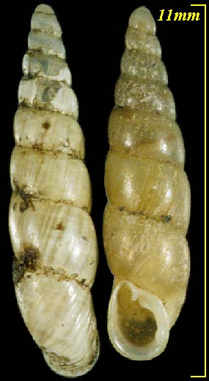

Spire has no limits: negative values trivially indicate an upside down shell.

Shape – The height of the oval tube divided by its width. A circle is a special case of a shape of I.

**Note – Program the computer to simulate the actual growth process varying around the leading edge of the tube and thereby performing ornate cross-sections.

“Modeling seashells” Deborah R. Fowlery_, Hans Meinhardtz and Przemyslaw Prusinkiewiczy

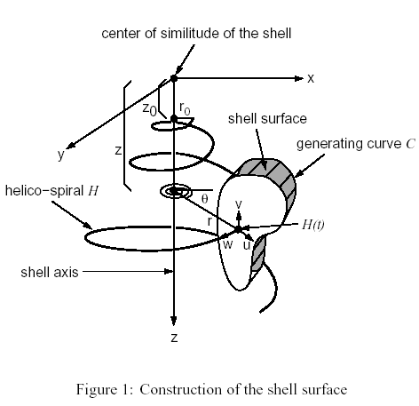

The modelling of a shell surface starts with the construction of a logarithmic (equiangular) helico-spiral H (Figure 1). In a cylindrical coordinate system (shown in Figure 1 as embedded in the Cartesian xyz) it has the parametric description:

θ = t, r = r₀E_{r}^{t}, z = z₀E_{z}^{t}

parameter t ranges from 0 at the apex(top) of the shell to t_{max} at the opening. The first two equations represent a logarithmic spiral lying rotated in the plane z = 0. The third equation stretches the spiral along the z-axis, thus contributing a helical component to its shape. Distances r and z are exponential functions of the parameter t, and usually have the same base, E_{r} = E_{z} = E. As a result, the generating helico-spiral is self-similar, with the centre of the similitude located at the origin of the coordinate system xyz. Given the initial conditions θ₀, r₀ and z₀, a sequence of points on the helico-spiral can be computed incrementally using the formulae:

θ_{I+1} = t_{i} + Δt = θ_{I} + Δθ
r = r₀E_{r}^{ti} E_{r} ^{Δt} = r_{i}λ_{r}
z = z₀E_{z}^{ti} E_{r} ^{Δt} = z_{i}λ_{z}
While the angle of rotation θ increases in arithmetic progression with the step Δθ, the radius r forms a geometric progression with the scaling factor λ_{r} = E_{r} ^{Δt}, and the vertical displacement forms a geometric progression with scaling factor λ_{z} = E_{z}^{t}. In many shells, parameters λ_{z} and λ_{t} are the same. Variations of shell shapes due primarily to different parameters of the helico-spiral are shown in Figure 2.

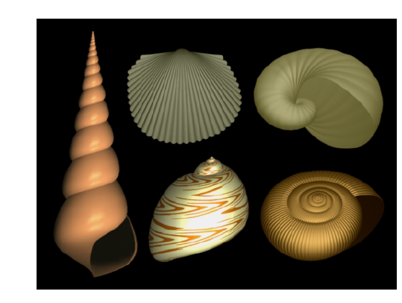
Figure 2: Variation of shell shapes resulting from different parameters of the helico-spiral. Leftmost: turbinate shell (z₀ = 1:9, Δθ = 1:007). Top row: patelliform shell (z₀ = 0, Δθ = 1:34) and tubular shell (z₀ = 0:0, Δθ = 1:011). Bottom row: spherical shell ( z₀ = 1:5, Δθ =1:03) and diskoid shell (z₀ = 1.4, _ = 1:014). All angles are in radians.

